CHAPTER 7
CONTINUOUS PROBABILITY DISTRIBUTIONS

SECTION EXERCISES
7.1 d/p/e Discrete probability distributions can be expressed as histograms where the height of the vertical bars is the probability for the various values that the random variable can take on. However, continuous probability distributions are smooth curves. Since the random variable can take on any value along a range, we find the probability that the random variable is within a certain interval by finding the area under the curve within this interval.

7.2 d/p/m A continuous probability distribution is a smooth curve. A probability density function is a function of x called f(x) which determines the shape of the curve. We speak of probabilities in terms of the probability that x will be within a specific interval of values. The probability density function is expressed in algebraic terms and the areas beneath it are obtained using calculus.

7.3 d/p/m The area beneath the probability density function represents the probability of the random variable, x, being between minus infinity and plus infinity. Since x must be between minus infinity and plus infinity (this is a certain event), the area must be 1.

7.4 d/p/e The probability of a continuous random variable taking on a specific value is 0 because there is an infinite number of possible values. The probability of any specific value is 0.

7.5 d/p/m There is an infinite number of normal curves possible. There are two descriptors that decide which specific curve you are talking about: the mean and the standard deviation.

7.6 d/p/e The normal distribution is symmetrical; the left side is a mirror image of the right side.

7.7 d/p/m Just superimpose part B of Figure 7.3 over part A so that the means are the same.

7.8 c/a/m x is normally distributed with μ = 20 and σ = 4. Using the approximate areas beneath the normal curve, as discussed in Section 7.2 of the chapter and shown in Figure 7.4:
a. P(x ≥ 20) = P(x ≥ μ) = 0.5
b. P(16 ≤ x ≤ 24) = P(μ - σ ≤ x ≤ μ + σ) = 0.683
c. P(x ≤ 12) = P(x ≤ μ - 2σ) = 0.5 – (0.955/2) = 0.5 - 0.4775 = 0.0225
d. P(x = 22) = 0
e. P(12 ≤ x ≤ 28) = P(μ - 2σ ≤ x ≤ μ + 2σ) = 0.955
f. P(x ≥ 16) = P(x ≥ μ - σ) = 0.5 + (0.683/2) = 0.5 + 0.3415 = 0.8415

7.9 c/a/m x is normally distributed with μ = 25 and σ = 5. Using the approximate areas beneath the normal curve, as discussed in Section 7.2 of the chapter and shown in Figure 7.4:
a. P(x ≥ 25) = P(x ≥ μ) = 0.5
b. P(20 ≤ x ≤ 30) = P(μ - σ ≤ x ≤ μ + σ) = 0.683
c. P(x ≤ 30) = P(x ≤ μ + σ) = 0.5 + (0.683/2) = 0.5 + 0.3415 = 0.8415
d. P(x = 26.2) = 0
e. P(15 ≤ x ≤ 25) = P(μ - 2σ ≤ x ≤ μ) = 0.955/2 = 0.4775
f. P(x ≥ 15) = P(x ≥ μ - 2σ) = 0.5 + (0.955/2) = 0.5 + 0.4775 = 0.9775

7.10 p/a/m Given x = revenue/passenger trip, x is normally distributed with μ = $1.55, σ = $0.20.
Using the approximate areas beneath the normal curve, as discussed in Section 7.2 of the chapter and shown in Figure 7.4:
a. P(x < 1.55) = P(x < μ) = 0.5
b. P(1.15 < x < 1.95) = P(μ - 2σ < x < μ + 2σ) = 0.955
c. P(1.35 < x < 1.75) = P(μ - σ < x < μ + σ) = 0.683
d. P(0.95 < x < 1.55) = P(μ - 3σ < x < μ) = 0.997/2 = 0.4985

7.11 p/a/m Given x = amount of first mortgage, normally distributed: μ = $360,000, σ = $30,000.
Using the approximate areas beneath the normal curve, as discussed in Section 7.2 of the chapter and shown in Figure 7.4:
a. P(x > 360,000) = P(x > μ) = 0.5
b. P(300,000 < x < 420,000) = P(μ - 2σ < x < μ + 2σ) = 0.955
c. P(330,000 < x < 390,000) = P(μ - σ < x < μ + σ) = 0.683
d. P(x > 270,000) = P(x > μ - 3σ) = 0.5 + (0.997/2) = 0.5 + 0.4985 = 0.9985

7.12 p/a/m Given x = tax preparation fees, normally distributed with μ = $187, σ = $20.
Using the approximate areas beneath the normal curve, as discussed in Section 7.2 of the chapter and shown in Figure 7.4:
a. P(x > 187) = P(x > μ) = 0.5
b. P(147 < x < 227) = P(μ - 2σ < x < μ + 2σ) = 0.955
c. P(167 < x < 207) = P(μ - σ < x < μ + σ) = 0.683
d. P(x > 227) = P(x > μ + 2σ) = 0.5 - (0.955/2) = 0.5 - 0.4775 = 0.0225

7.13 p/a/m Given x = times for check-in and bag delivery, normally distributed with μ = 12.0 mins.,
σ = 2.0 mins. Using the approximate areas beneath the normal curve, as discussed in Section 7.2 of the chapter and shown in Figure 7.4:
a. P(x > 14) = P(x > μ + σ) = 0.5 - (0.683/2) = 0.5 - 0.3415 = 0.1585
b. P(10 < x < 14) = P(μ - σ < x < μ + σ) = 0.683
c. P(x < 8) = P(x < μ - 2σ) = 0.5 - (0.955/2) = 0.5 - 0.4775 = 0.0225
d. P(10 < x < 16) = P(μ - σ < x < μ + 2σ) = (0.683/2) + (0.955/2) = 0.3415 + 0.4775 = 0.819

7.14 p/a/m Given x = annual spending on food prepared at home, normally distributed with μ = $5000, and σ = $1000. Using the approximate areas beneath the normal curve, as discussed in Section 7.2 of the chapter and shown in Figure 7.4:
a. P(x > 8000) = P(x > μ + 3σ) = 0.5 - (0.997/2) = 0.5 - 0.4985 = 0.0015
b. P(5000 < x < 7000) = P(μ < x < μ + 2σ) = 0.955/2 = 0.4775
c. P(x < 6000) = P(x < μ + σ) = 0.5 + (0.683/2) = 0.5 + 0.3415 = 0.8415
d. P(3000 < x < 6000) = P(μ - 2σ < x < μ + σ) = (0.955/2) + (0.683/2) = 0.4775 + 0.3415 = 0.819

7.15 p/a/m Given x = commuting times, normally distributed with μ = 30.0 mins., σ = 5.0 mins.
Using the approximate areas beneath the normal curve, as discussed in Section 7.2 of the chapter and shown in Figure 7.4:
a. P(x > 45.0) = P(x > μ + 3σ) = 0.5 - (0.997/2) = 0.5 - 0.4985 = 0.0015
b. P(x < 25.0) = P(x < μ - σ) = 0.5 - (0.683/2) = 0.5 - 0.3415 = 0.1585 It would be a good idea for him to update his resume.

7.16 d/p/m The standard normal distribution is not a family of distributions. It is a particular normal distribution with a mean of 0 and a standard deviation of 1.

7.17 d/p/m
a. 25% of the time, z is less than the first quartile. P(z < Q) = 0.25. Look up the cumulative area 0.2500 in the body of the standard normal table; taking the closest value, Q = -0.67.
25% of the time, z is greater than the third quartile. P(z > Q) = 0.25, so P(z < Q) = 0.7500.
Look up the cumulative area 0.7500 in the body of the standard normal table; taking the closest value,
Q = +0.67.
b. 10% of the time, z is less than the first decile. P(z < D) = 0.10. Look up the cumulative area 0.1000 in the body of the standard normal table; taking the closest value, D = -1.28.
10% of the time, z is greater than the ninth decile. P(z > D) = 0.10, so P(z < D) is 0.9000.
Look up the cumulative area 0.9000 in the body of the standard normal table; taking the closest value, D = +1.28.
c. 23% of the time, z is less than the 23rd percentile. P(z < P) = 0.23. Look up the cumulative area 0.2300 in the body of the standard normal table; taking the closest value, P = -0.74.
23% of the time, z is greater than the 77th percentile. P(z > P) = 0.23, so P(z < P) is 0.7700.
Look up the cumulative area 0.7700 in the body of the standard normal table; taking the closest value, P = +0.74.

7.18 c/p/e Given x is normally distributed with μ = 1000 and σ = 100.
a. x = 1000 z = (x - μ)/σ = (1000 - 1000)/100 = 0.00
b. x = 750 z = (750 - 1000)/100 = -2.50 c. x = 1100 z = (1100 - 1000)/100 = 1.00
d. x = 950 z = (950 - 1000)/100 = -0.50 e. x = 1225 z =(1225 - 1000)/100 = 2.25

7.19 c/p/e Given x is normally distributed with μ = 200 and σ = 25.
a. x = 150 z = (x - μ)/σ = (150 - 200)/25 = -2.00
b. x = 180 z = (180 - 200)/25 = -0.80 c. x = 200 z = (200 - 200)/25 = 0.00
d. x = 285 z = (285 - 200)/25 = 3.40 e. x = 315 z = (315 - 200)/25 = 4.60

7.20 c/a/e
a. P(0.00 ≤ z ≤ 1.25): Referring to the "1.2" row and the "0.05" column of the standard normal table, the cumulative area to z = 1.25 is 0.8944. Referring to the “0.0” row and the “0.00” column of the standard normal table, the cumulative area to z = 0.00 is 0.5000. P(0.00 ≤ z ≤ 1.25) is the cumulative area to z = 1.25 minus the cumulative area to z = 0.00, or 0.8944 - 0.5000 = 0.3944.
b. P(-1.25 ≤ z ≤ 0.00): This is the cumulative area to z = 0.00 minus the cumulative area to z = -1.25, or 0.5000 - 0.1056 = 0.3944.
c. P(-1.25 ≤ z ≤ 1.25): This is the cumulative area to z = 1.25 minus the cumulative area to z = -1.25, or 0.8944 - 0.1056 = 0.7888.

7.21 c/a/e
a. P(0.00 ≤ z ≤ 1.10): This is the cumulative area to z = 1.10 minus the cumulative area to z = 0.00,
or 0.8643 - 0.5000 = 0.3643.
b. P(z ≥ 1.10): This is the total cumulative beneath the curve (i.e., a z value of +infinity) minus the
cumulative area to z = 1.10, or 1.0000 - 0.8643 = 0.1357.
c. P(z ≤ 1.35): Referring to the “1.3” row and the “0.05” column of the standard normal table,
the cumulative area to z = 1.35 is 0.9115.

7.22 c/a/e
a. P(-0.36 ≤ z ≤ 0.00): This is the cumulative area to z = 0.00 minus the cumulative area to z = -0.36,
or 0.5000 - 0.3594 = 0.1406.
b. P(z ≤ -0.36): Referring to the “-0.3” row and the “0.06” column, the cumulative area to z = -0.36 is 0.3594.
c. P(z ≥ -0.43): This is the total cumulative beneath the curve (i.e., a z value of +infinity) minus the
cumulative area to z = -0.43, or 1.0000 - 0.3336 = 0.6664.

7.23 c/a/e
a. P(-1.96 ≤ z ≤ 1.27): This is the cumulative area to z = 1.27 minus the cumulative area to z = -1.96,
or 0.8980 - 0.0250 = 0.8730.
b. P(0.29 ≤ z ≤ 1.00): This is the cumulative area to z = 1.00 minus the cumulative area to z = 0.29,
or 0.8413 - 0.6141 = 0.2272.
c. P(-2.87 ≤ z ≤ -1.22): This is the cumulative area to z = -1.22 minus the cumulative area to z = -2.87,
or 0.1112- 0.0021 = 0.1091.

7.24 c/p/m
a. P(z ≤ z₀) = 0.7486: Look up the area 0.7486 in the body of the standard normal table. The z value for this cumulative area will be z₀ = 0.67.
b. P(z ≤ z₀) = 0.0735: Look up the area 0.0735 in the body of the standard normal table. The z value for this cumulative area will be z₀ = -1.45.
c. P(z ≥ z₀) = 0.3508: If the area to the right of z₀ is 0.3508, then the cumulative area to the left is
1.0000 - 0.3508 = 0.6492. Looking for a cumulative area of 0.6492 in the body of the normal table,
we find the nearest value in the table corresponds to z₀ = 0.38.
d. P(z ≥ z₀) = 0.0212: If the area to the right of z₀ is 0.0212, then the cumulative area to the left is
1.0000 - 0.0212 = 0.9788. Looking for a cumulative area of 0.9788 in the body of the normal table,
we find z₀ = 2.03.

7.25 c/p/m
a. P(z ≤ z₀) = 0.7000: Looking for a cumulative area of 0.7000 in the body of the normal table,
we find the nearest value in the table corresponds to z₀ = 0.52.
b. P(z ≤ z₀) = 0.1000: Looking for a cumulative area of 0.1000 in the body of the normal table,
we find the nearest value in the table corresponds to z₀ = -1.28.
c. P(z ≤ z₀) = 0.5400: Looking for a cumulative area of 0.5400 in the body of the normal table,
we find the nearest value in the table corresponds to z₀ = 0.10.
c. P(z ≥ z₀) = 0.3000: If the area to the right of z₀ is 0.3000, then the cumulative area to the left is
1.0000 - 0.3000 = 0.7000. Looking for a cumulative area of 0.7000 in the body of the normal table,
we find the nearest value in the table corresponds to z₀ = 0.52.

7.26 p/a/m From exercise 7.10, x is normally distributed with μ = $1.55 and σ = $0.20.
a. P(1.55 < x < 1.80) = P(0.00 < z < 1.25) = 0.8944 - 0.5000 = 0.3944
b. P(x > 1.90) = P(z > 1.75) = 1.0000 - 0.9599 = 0.0401
c. P(x < 1.25) = P(z < -1.50) = 0.0668

7.27 p/a/m From exercise 7.11, x is normally distributed with μ = $360,000 and σ = $30,000.
a. P(305,000 < x < 325,000) = P(-1.83 < z < -1.17) = 0.1210 - 0.0336 = 0.0874
b. P(x > 325,000) = P(z > -1.17) = 1.0000 - 0.1210 = 0.8790
c. P(x < 390,000) = P(z < 1.00) = 0.8413

7.28 p/a/m From exercise 7.12, x is normally distributed with μ = $187 and σ = $20.
a. P(150 < x < 180) = P(-1.85 < z < -0.35) = 0.3632 - 0.0322 = 0.3310
b. P(x < 140) = P(z < -2.35) = 0.0094
c. P(x > 220) = P(z > 1.65) = 1.0000 - 0.9505 = 0.0495

7.29 p/a/m From exercise 7.15, x is normally distributed with μ = 30.0 minutes and σ = 5 minutes.
a. P(x < 29) = P(z < -0.20) = 0.4207
b. P(29 < x < 33) ) = P(-0.20 < z < 0.60) = 0.7257 - 0.4207 = 0.3050
c. P(x > 32) = P(z > 0.40) = 1.0000 - 0.6554 = 0.3446

7.30 p/a/d From exercise 7.15, x is normally distributed with μ = 30.0 minutes and σ = 5 minutes.
The quantity to be determined is the commuting time (A) such that only 10% of Jamal’s commutes would exceed A minutes.
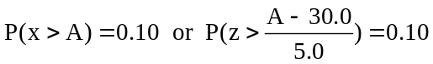
To solve for A, we must first find the value of z which corresponds to a cumulative area of
1.0000 - 0.1000, or 0.9000. Looking for a cumulative area of 0.9000 in the body of the standard normal table, we find the nearest value to be 0.8997, so we will use z = 1.28 in our next calculation:
Equating 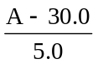to 1.28, solve for A, and A = 36.4 minutes. Only 10% of Jamal’s commutes will be longer than 36.4 minutes.

7.31 p/a/d From exercise 7.11, x is normally distributed with μ = $360,000 and σ = $30,000.
The quantity to be determined is the first-mortgage amount (A) such that only 5% of the mortgage customers exceed A dollars.
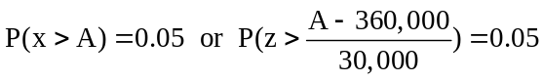
To solve for A, we must first find the value of z which corresponds to a cumulative area of
1.0000 - 0.0500, or 0.9500. Looking for a cumulative area of 0.9500 in the body of the standard normal table, we find the nearest values to be 0.9495 and 0.9505. They are equally distant from 0.9500, and we will interpolate to obtain a z value that is halfway between 1.64 and 1.65, or z = 1.645:
P(z > 1.645) = 0.05. Equating 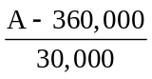to 1.645, solve for A, and A = $409,350.

7.32 p/a/d From exercise 7.12, x is normally distributed with μ = $187 and σ = $20.
The quantity to be determined is the tax preparation fee (F) such that 90% of the tax preparation customers exceed F dollars.
P(x > F) = 0.90 or P(z > 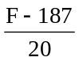) = 0.90
We must first find the z value for which the area to the right is 0.9000. The cumulative area to the left will be 1.0000 - 0.9000 = 0.1000. Referring to the body of the standard normal table, we find the cumulative area closest to 0.1000 is 0.1003, and it corresponds to z = -1.28.
Equating 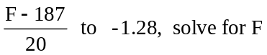, and F = $161.40.

7.33 p/a/m Given x = annual expenditure is normally distributed with μ = $6050, σ = $1500.
a. P(x > 6350) = P(z > 0.20) = 1.0000 - 0.5793 = 0.4207
b. We are looking for the z value corresponding to a cumulative area of 0.9900 in the standard normal table. The closest value is z = 2.33. Solving (E - 6050)/1500 = 2.33, we obtain E = $9545.

7.34 p/a/d Let x = distance traveled by the circus performer, with μ = 150 ft., σ = 10 ft.
a. To maximize Andre's probability of landing on the net, position the net so the center is at the mean. The net must then be placed 150 - 15 = 135 feet from the cannon.
b. 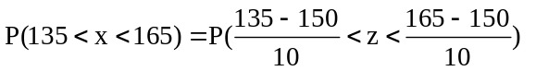 = P(-1.50 < z < 1.50) = 0.9332 - 0.0668 = 0.8664

7.35 p/a/d Let x = drying time. The distribution is normal with μ = 2.5 mins. and σ = 0.25 mins.
We need to find the z value that corresponds to a cumulative area of 0.9980. From the standard normal table, we find this z value to be z = 2.88. 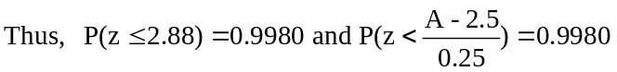

7.36 p/a/d The pump lifetimes are currently normally distributed with μ = 63,000 miles and σ = 10,000 miles.
a. For 50,000 miles, z will be (50,000 – 63,000)/10,000 = -1.30.
P(x < 50,000) = 0.0968, and 9.68% of the pumps will fail before 50,000 miles.
b. P(x = 50,000) = 0.
c. P(40,000 < x < 55,000) = P(-2.30 < z < -0.80) = 0.2119 - 0.0107 = 0.2012, and 20.12% of the pumps will fail between 40,000 and 50,000 miles.
d. The quantity to be determined is the mileage (A) such that 80% of the pumps will have a lifetime
less than A.
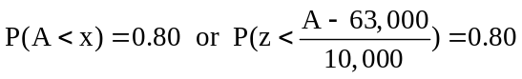
Using the standard normal table, find the z value for which the cumulative area is 0.8000.
The nearest table value is an area of 0.7995, corresponding to z = 0.84.
Equating 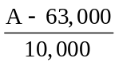to 0.84, solve for A, and A = 71,400 miles. The probability is 0.80 that a pump
will fail before it has been in use for 71,400 miles.

7.37 p/a/d The pump lifetimes are currently normally distributed with μ = 63,000 miles and σ = 10,000 miles. The mean will now have to be a value such that the cumulative area to the left of x = 50,000 is just 0.0200. For a cumulative area of 0.0200, the nearest area listed is 0.0202, associated with z = -2.05.
We can now set up an expression that can be solved for the value of the necessary mean, M:
This is 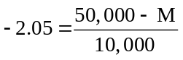and, solving for M, we find that M = 70,500 miles.

7.38 p/a/d Assume the battery lifetimes to be normally distributed with μ = 8 hours and σ = 2 hours.
In order for Edgar to be rescued during the night, his flashlight must be able to shine longer than the 6 hours from 9 PM to 3 AM. The z value associated with P(x > 6) hours is (6 - 8)/2, or z = -1.00.
Using the standard normal table, P(x > 6) = P(z > -1.00) = 1.000 - 0.1587 = 0.8413. There is a 0.8413 probability that Edgar’s flashlight will work long enough for him to be seen and rescued.

7.39 d/p/m The correction expands each possible value of a discrete variable by 0.5 in each direction. This is needed because the binomial distribution is discrete (having gaps between the possible values) while the normal distribution is continuous and can take on any value within an interval.

7.40 d/p/m The normal approximation to the binomial distribution is quite close whenever both nπ and n(1 - π) are ≥ 5.

7.41 c/a/m
a. μ = nπ = 40(0.25) = 10.0 and 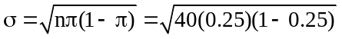= 2.739
b. P(x = 8) = P(7.5 ≤ x ≤ 8.5) after continuity correction.
P(12 ≤ x ≤ 16) = P(11.5 ≤ x ≤ 16.5) after continuity correction.
P(10 ≤ x ≤ 12) = P(9.5 ≤ x ≤ 12.5) after continuity correction.
P(x ≥ 14) = P(x ≥ 13.5) after continuity correction.
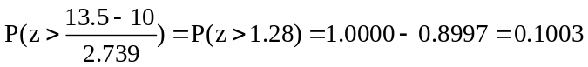

7.42 c/a/m
a. μ = nπ = 20(0.30) = 6.0 and 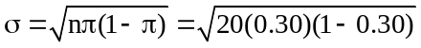= 2.049
b. P(x = 5) = P(4.5 ≤ x ≤ 5.5) after continuity correction.
P(4 ≤ x ≤ 7) = P(3.5 ≤ x ≤ 7.5) after continuity correction.
P(1 ≤ x ≤ 5) = P(0.5 ≤ x ≤ 5.5) after continuity correction.
P(x ≥ 7) = P(x ≥ 6.5) after continuity correction.
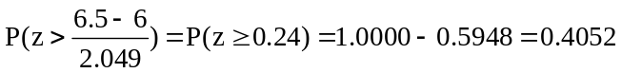

7.43 p/a/d Given x is binomial with π = 0.80 and n = 15.
a. μ = nπ = 15(0.80) = 12.0 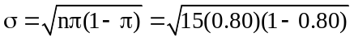 = 1.549
b. Referring to the individual binomial tables in the appendix, P(x = 12) = 0.2501.
c. Using the normal approximation to the binomial distribution: P(x = 12) = P(11.5 ≤ x ≤ 12.5)
after continuity correction, = P(-0.32 ≤ z ≤ 0.32) = 0.6255 - 0.3745 = 0.2510.
d. Using the normal approximation to the binomial distribution: P(x ≥ 10) = P(x ≥ 9.5)
after continuity correction, = P(z ≥ -1.61) = 1.0000 - 0.0537 = 0.9463.

7.44 p/a/d Given x is binomial with π = 0.40 and n = 20.
a. μ = nπ = 20(0.40) = 8.0 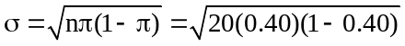 = 2.191
b. P(x = 8) = 0.1797 from the table of individual binomial probabilities.
c. P(6 ≤ x ≤ 9) = P(x ≤ 9) - P(x ≤ 5) = 0.7553 - 0.1256 = 0.6297 from the table of cumulative binomial probabilities.
d. Using the normal approximation to the binomial distribution: P(x = 8) = P(7.5 ≤ x ≤ 8.5)
after continuity correction, = P(-0.23 ≤ z ≤ 0.23) = 0.5910 - 0.4090 = 0.1820.
e. Using the normal approximation to the binomial distribution: P(6 ≤ x ≤ 9) = P(5.5 ≤ x ≤ 9.5)
after continuity correction, = P(-1.14 ≤ z ≤ 0.68) = 0.7517 - 0.1271 = 0.6246.

7.45 p/a/m Let x = the number of tax returns in this group prepared by H & R Block, x is binomial with
π = 0.158 and n = 900.
μ = nπ = 900(0.158) = 142.2 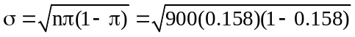= 10.942
Using the normal approximation to the binomial distribution: P(110 ≤ x ≤ 140) = P(109.5 ≤ x ≤ 140.5) after continuity correction, = P(-2.99 ≤ z ≤ -0.16) = 0.4364 - 0.0014 = 0.4350.

7.46 p/a/m Let x = the number of households in this group that have a camcorder, x is binomial with
π = 0.50 and n = 800.
μ = nπ = 800(0.50) = 400 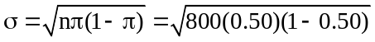= 14.142
Using the normal approximation to the binomial distribution: P(x ≥ 410) = P(x ≥ 409.5) after continuity correction, = P(z ≥ 0.67) = 1.0000 - 0.7486 = 0.2514.

7.47 p/a/m From exercise 7.45, x is binomial with π = 0.158 and n = 900, μ = 142.2, σ = 10.942.
Without continuity correction, P(110 ≤ x ≤ 140) = P(-2.94 ≤ z ≤ -0.20) = 0.4207 - 0.0016 = 0.4191.
With the continuity correction, P(110 ≤ x ≤ 140) was equal to 0.4350. The probabilities differ by just 0.0159. The larger n is or the closer π is to 0.5, the less important the correction becomes.

7.48 p/a/m From exercise 7.46, x is binomial with π = 0.50 and n = 800, μ = 400, σ = 14.142.
Without continuity correction, P(x ≥ 410) = P(z ≥ 0.71) = 1.0000 – 0.7611 = 0.2389.
With the continuity correction, P(x ≥ 410) was 0.2514. The probabilities differ by just 0.0125.
The larger n is or the closer π is to 0.5, the less important the correction becomes.

7.49 d/p/e The Poisson distribution describes a discrete random variable which is the number of "rare events" occurring during a given interval of time, space, or distance. For a Poisson process, the exponential distribution describes a continuous random variable, x = the amount of time, space, or distance between occurrences of these rare events.

7.50 d/p/m A Poisson random variable would be x = the number of drivers who have the correct change in an hour. The exponential-distribution counterpart would be y = the hours between drivers who have the correct change.

7.51 d/p/m A Poisson random variable would be x = the number of calls from customers in a minute.
The exponential-distribution counterpart would be y = minutes between calls from customers.

7.52 c/a/m With x exponentially distributed with mean = 1/ λ = 1/1.5 = 2/3,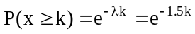
a. 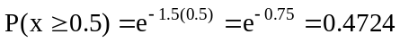 b. 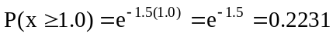
c. 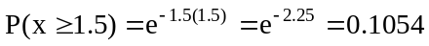 d. 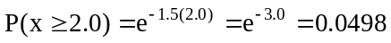

7.53 c/a/m With x exponentially distributed with mean = 1/ λ = 1/0.02 = 50, 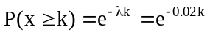
a. 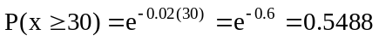 b. 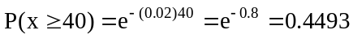
c. 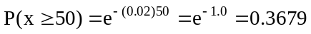 d. 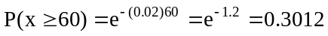

7.54 c/a/m With x exponentially distributed with mean = 1/ λ = 1/0.5 = 2.0, 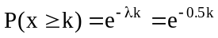
a. 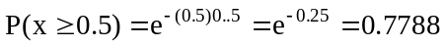and P(x ≤ 0.5) = 1 - 0.7788 = 0.2212
b. 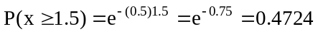 and P(x ≤ 1.5) = 1 - 0.4724 = 0.5276
c. 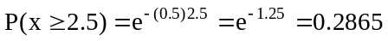 d. 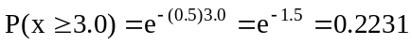

7.55 p/a/m The mean of the corresponding Poisson distribution would be λ = 1/8 = 0.125, so
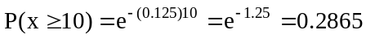

7.56 p/a/d Given x is exponentially distributed with a mean of 1/λ = 5.3 minutes:
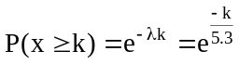
and

7.57 p/a/d The variable x = thousands of flying hours between fatal crashes is exponentially distributed with a mean of 1/λ = 1/0.0120 = 83.33 thousand flying hours, and Arnold’s Flying Service flies 40 thousand hours each year.
The probability that Arnold’s will not experience a fatal crash until at least a year from today, or until at least x = 40 thousand flying hours, is 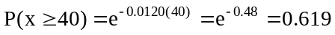.
The probability that Arnold’s will not experience a fatal crash until at least two years from today, or until at least x = 80 thousand flying hours, is 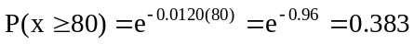.
This is most easily done with the computer. We want the inverse of the cumulative probability distribution, and the specific cumulative probability of interest is 1 - 0.90, or 0.10. As shown in the Minitab printout below, there is a 0.10 probability that the next fatal crash will occur within the next 8.7797 thousand flying hours.

Inverse Cumulative Distribution Function
Exponential with mean = 83.33

P( X <= x ) x
0.1 8.77969

Accordingly, there is a 0.90 probability that no fatal crash will occur until at least 8.7797 thousand flying hours from now. This can also be expressed as
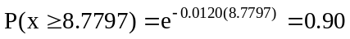.

7.58 p/a/d We can express λ as 5(0.006) = 0.03 fatalities per million worker-hours. The mean of the corresponding exponential distribution is 1/λ = 1/0.03 = 33.3 million worker-hours between fatalities. Regardless of how many worker-hours occur in the industry, the expected number of worker-hours until the next fatality is the mean of the distribution, or 33.3 million worker-hours.
Over the next 30 years, the company will have 30 million worker-hours. The probability that the next fatal injury in this company will not occur until at least 30 years from now is
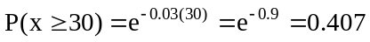.

7.59 c/p/m
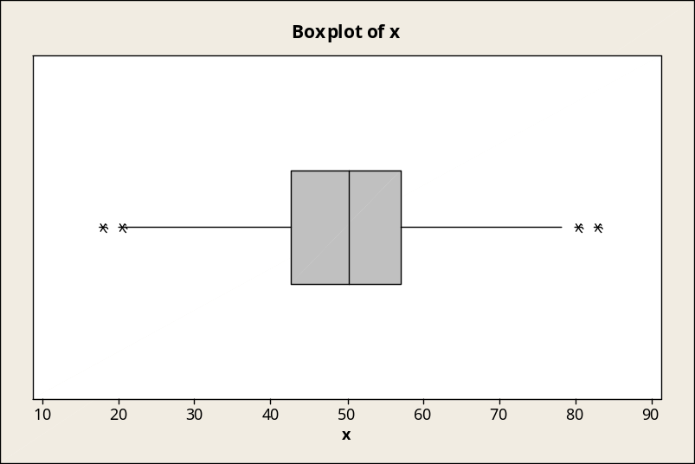

7.60 c/p/m
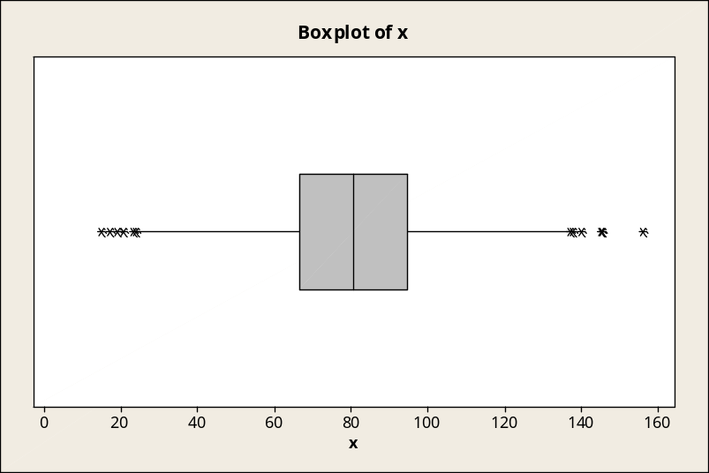

7.61 c/a/m Given x is normally distributed with μ = 150 and σ = 25.
P(x ≤ 140) = P(x ≤ μ - 0.40σ) = P(z ≤ -0.40) = 0.3446
We would expect 689.2 of the 2000 observations (34.46%) to have a value of 140 or less. The actual number would not be equal to the expected number. However, the more observations we select the closer we will tend to come to what we expect.

7.62 c/a/m Given x is normally distributed with μ = 200 and σ = 50.
P(x ≥ 300) = P(x ≥ μ + 2σ) = P(z ≥ 2.00) = 1.0000 - 0.9772 = 0.0228
We would expect 22.8 of the 1000 observations (2.28%) to have a value of 300 or more. The actual number would not be equal to the expected number. However, the more observations we select the closer we will tend to come to what we expect.

CHAPTER EXERCISES
7.63 p/a/d Let x = the number of jurors that are charge-account holders; x is binomial with n = 9 and
π = 0.35. Since nπ = 9(0.35) = 3.15 is less than 5, we cannot use the normal approximation to the binomial. Using the binomial distribution and Minitab cumulative probabilities:

Binomial with n = 9 and p = 0.350000
x P( X <= x)
0 0.0207
1 0.1211
2 0.3373
3 0.6089

P(x ≥ 4) = 1 – P(x ≤ 3) = 1 – 0.6089 = 0.3911

7.64 p/a/m Let x = the number of subjects who prefer soft drink A; x is binomial with n = 200 and
π = 0.5 (assuming there is no difference in the taste of A and B). Using the normal approximation to the binomial,
μ = nπ = 200(0.5) = 100 and 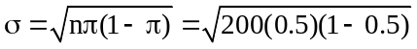= 7.071
P(x ≥ 110) = P(x ≥ 109.5) after continuity correction.
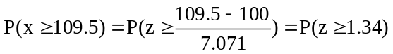= 1.0000 - 0.9099 = 0.0901

7.65 p/p/d According to exercise 7.64, 9.01% of the time at least 110 out of 200 persons would say they like soft drink A better than B even if the soft drinks are not really different. Soft drink A might be superior to B since 110 out of 200 persons did say they like soft drink A better than B. However, this could be just a chance occurrence.

7.66 p/a/m Let x = the gas bill for customers in this community heating their homes with gas;
x is normally distributed with μ = $457 and σ = $80.
a.
b.
= 0.8413 - 0.6915 = 0.1498
c. The quantity to be determined is the gas bill (G) such that only 2.5% of the homes' gas bills
exceed G dollars, or P(x > G) = 0.025. First, find the value of z that corresponds to a cumulative
area of 1.0000 - 0.0250 = 0.9750. Referring to the standard normal table, we find that a cumulative area of 0.9750 corresponds to z = 1.96. Now substitute μ = 457, σ = 80, and z = 1.96 into the z-score formula:
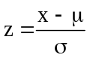 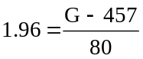 Solving for G: G = $613.80
d. The quantity to be determined is the gas bill (G) such that 95% of the homes' gas bills exceed
G dollars, or P(x > G) = 0.95. First, find the value of z that corresponds to a cumulative area
of 1.0000 - 0.9500 = 0.0500. Referring to the standard normal table, we find that a cumulative area of 0.0500 corresponds to z = -1.645. Now substitute μ = 457, σ = 80, and z = -1.645 into the z-score formula:
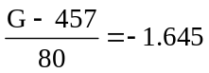 Solving for G: G = $325.40

7.67 p/a/m Let x = monthly cell phone bills; x is normally distributed with μ = $50 and σ = $10
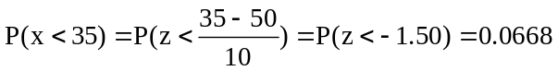

7.68 p/a/m Let x = the flying hours for aircraft operated by regional airlines in the U.S.; x is normally distributed with μ = 2389 and σ = 300.
a.
b.
= 0.5160 - 0.0968 = 0.4192
c. The quantity to be determined is the annual flying hours (F) such that only 15% of the aircraft
exceed F hours, or P(x > F) = 0.15. First, find the value of z that corresponds to a cumulative area
of 1.0000 - 0.1500 = 0.8500. Referring to the standard normal table, we find that a cumulative area of 0.8500 most closely corresponds to z = 1.04. Now substitute μ = 2389, σ = 300, and z = 1.04 into the z-score formula.
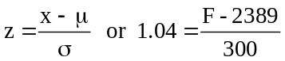 Solving for F: F = 2701 hours
d. The quantity to be determined is the annual flying hours (F) such that 75% of the aircraft exceed
F hours, or P(x > F) = 0.75. First, find the value of z that corresponds to a cumulative area
of 1.0000 - 0.7500 = 0.2500. Referring to the standard normal table, we find that a cumulative area of 0.2500 most closely corresponds to z = -0.67. Now substitute μ = 2389, σ = 300, and z = -0.67 into the z-score formula.
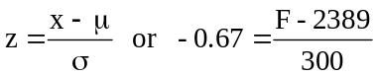 Solving for F: F = 2188 hours

7.69 p/a/m Let x = the daily volume of packages for FedEx; x is normally distributed with
μ = 7,000,000 and σ = 800,000.
= P(-1.25 < z < -0.63) = 0.2643 - 0.1056 = 0.1587

7.70 p/a/m Let x = charitable contribution; x is normally distributed with μ = $1935 and σ = $400.
a. 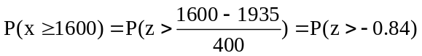 = 1.0000 - 0.2005 = 0.7995
b. 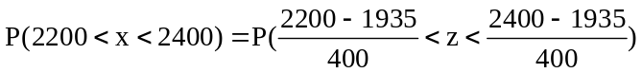
= P(0.66 < z < 1.16) = 0.8770 - 0.7454 = 0.1316

c. The quantity to be determined is the level of contributions (C) such that only 20% of the itemized returns in this group exceed C dollars, or P(x > C) = 0.20. First, find the value of z that corresponds to a cumulative area of 1.0000 - 0.2000 = 0.8000. Referring to the standard normal table, we find that a cumulative area of 0.8000 most closely corresponds to z = 0.84. Now substitute μ = 1935, σ = 400, and z = 0.84 into the z-score formula:
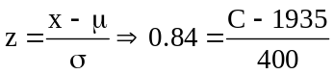 Solving for C: C = $2271

d. The quantity to be determined is the level of contributions (C) such that 40% of the itemized
returns in this group exceed C dollars, or P(x > C) = 0.4. First, find the value of z that corresponds to a cumulative area of 1.0000 - 0.4000 = 0.6000. Referring to the standard normal table, we find that a cumulative area of 0.6000 most closely corresponds to z = 0.25.
Now substitute μ = 1935, σ = 400, and z = 0.25 into the z-score formula:
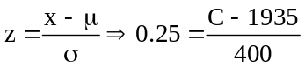 Solving for C: C = $2035

7.71 p/a/m Let x = the number of persons of voting age in the sample that voted in the 2008 presidential election; x is binomial with n = 30 and π = 0.72. Since nπ = 30(0.72) = 21.6 and
n(1 - π) = 30(1 – 0.72) = 8.4 are both larger than 5, we can use the normal approximation.
μ = nπ = 30(0.72) = 21.6, 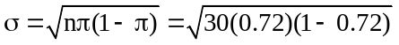 = 2.459
Applying the correction for continuity:

7.72 p/a/d Let x = the number of persons interviewed who felt the company to be an industry leader; x is binomial with n = 500 and π = 0.8 (assuming the public relations agency's claim is correct). We will use the normal approximation to the binomial.
μ = nπ = 500(0.8) = 400, 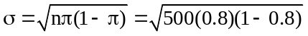 = 8.944
Applying the correction for continuity:
P(x ≤ 320) = P(x ≤ 320.5) = 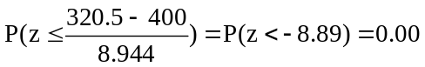

7.73 p/a/d According to exercise 7.72, if the public relations agency's claim is correct, there is practically no chance whatsoever of only 320 or fewer people out of 500 feeling the company is an industry leader.
Therefore, if the survey taken was a good random sample of the residents in a 50-mile radius, the public relations agency's claim does not appear to be correct.

7.74 p/a/d Let x = minutes between occurrences, x is exponentially distributed. The best estimate of the mean (1/λ) would be:
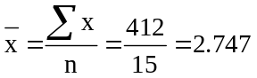
The mean of the corresponding Poisson distribution is the inverse of the mean of the exponential distribution. The best estimate of the mean (λ) is 1/2.747 = 0.364.

7.75 p/a/m 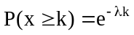The mean and standard deviation of the exponential distribution (1/λ) is:
1/λ 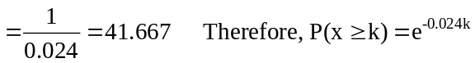 and

7.76 p/a/m The mean of the exponential distribution is 1/λ = 1/0.035 = 28.571.
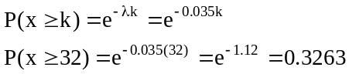

7.77 p/a/m Let x = the number of years until the next highway motorcycle fatality. For the club members, we would expect 0.39 deaths per 1 million miles or 0.78 deaths per 2 million miles (one year of travel).
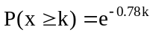 and 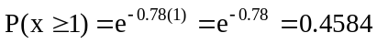
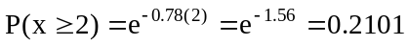

7.78 p/a/m Let x = the actual weight of the package of cheese in ounces; x is normally distributed with
μ = 21 and σ = 0.2.
a. P(x ≥ 20.5) = 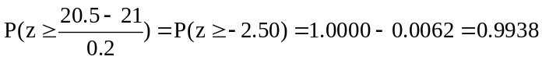
b. P(20.5 ≤ x ≤ 21.3)
=
c. First, we need to find the probability of one package containing at least 21.2 ounces of cheese.
Let y = the number of packages selected that contain at least 21.2 ounces of cheese, y is binomial with n = 8 and n = 0.1587. Using Minitab and the cumulative probabilities listed below in finding P(y ≥ 3):

Binomial with n = 8 and p = 0.158700
x P( X <= x)
0 0.2510
1 0.6297
2 0.8797

and P(y ≥ 3) = 1- P(y ≤ 2) = 1 - 0.8797 = 0.1203.

7.79 p/a/d Let x = the score on the exam; assume x is normally distributed with μ = 81, σ = 8.5.

7.80 p/a/d Let x = game minutes between sprained ankles; x is exponentially distributed with a mean of 1/λ = 1/0.0023 = 434.783.
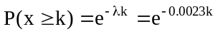
a. P(x ≤ 60) =
b. P(x ≤ 600) =
c. P(x = 58) = 0 since x is a continuous random variable.

7.81 p/a/d Let x = the actual precooked hamburger weight, and x is normally distributed with μ = 5.5 ounces and σ = 0.15 ounces. The probability that the journalist will receive a hamburger with a precooked weight less than 5.3 ounces is
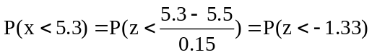= 0.0918
The probability that at least 2 of the four customers will receive a hamburger with precooked weight greater than 5.7 ounces:
First, for a single hamburger, 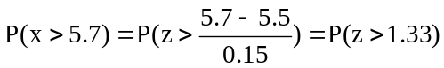= 1.0000 - 0.9082 = 0.0918.
For a binomial process with n = 4 trials and π = 0.0918, we can find P(x ≥ 2) either with the pocket calculator and the methods of chapter 6, or with the computer. The Minitab printout and cumulative probabilities are shown below.

Binomial with n = 4 and p = 0.0918000
x P( X <= x )
0.00 0.6803
1.00 0.9554
2.00 0.9971
3.00 0.9999
4.00 1.0000

and P(x ≥ 2) = 1 - P(x ≤ 1) = 1 - 0.9554 = 0.0446.

7.82 p/a/d Let x = the actual weight of the package contents, and x is normally distributed with
μ = 20.3 ounces and σ = 0.3 ounces.
P(20 ≤ x ≤ 21)
=
The probability that any single box will contain less than 20.0 ounces
= 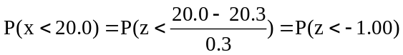= 0.1587
For a binomial process with n = 100 trials, π = 0.1587, and x = the number of boxes that contain less than 20.0 ounces, we can find P(x ≥ 5) either with the pocket calculator and the methods of chapter 6, or with the computer. The Minitab printout and cumulative probabilities are shown below.

Binomial with n = 100 and p = 0.158700
x P( X <= x )
0.00 0.0000
1.00 0.0000
2.00 0.0000
3.00 0.0000
4.00 0.0002
5.00 0.0008
6.00 0.0024
7.00 0.0067
8.00 0.0160
9.00 0.0340
10.00 0.0649

With P(x > 5) = 1 - P(x ≤ 5) = 1 - 0.0008 = 0.9992, it’s virtually certain the company will be sued.
We could also use the normal approximation to the binomial distribution in solving this portion of the exercise. The descriptors of the relevant normal distribution are μ = nπ = 100(0.1587) = 15.87 and = 3.654.

7.83 p/a/d The quantity to be determined is the mean weight (M) that would result in just 2% of the packages containing less than 20 ounces. First, find the value of z corresponding to a cumulative area of 0.0200. Referring to the standard normal table, we find this to be z = -2.05.
Now substitute μ = M, σ = 0.3, and z = -2.05 into the z-score formula:
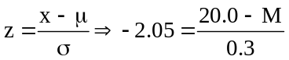 Solving for M: M = 20.615 ounces, the necessary mean.

7.84 p/a/m Given x is binomial with n = 40 and π = 250/2000 = 0.125; since nπ = 40(0.125) = 5.0
and n(1 - π) = 40(1 - 0.125) = 35.0 are ≥ 5, we can use the normal approximation to the binomial.
μ = nπ = 40(0.125) = 5.0 and 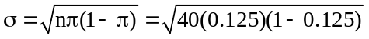 = 2.09

With x = the number of defective computers received, and using the correction for continuity:
P(0 ≤ x ≤ 2) = P(-0.5 ≤ x ≤ 2.5) after continuity correction,
and

P(1 ≤ x ≤ 3) = P(0.5 ≤ x ≤ 3.5) after continuity correction,
and
We could also use the binomial distribution and the computer, treating this as a binomial process with
n = 40 trials, π = 0.125, and x = number of defective computers in the shipment received by the firm.

7.85 p/a/d
a. The mean of the Poisson distribution is λ = 1.25/10,000, or 0.000125 punctures per mile. Its inverse is the mean of the corresponding exponential distribution, 1/λ = 8000 miles between punctures.
The probability they will not have to change any tires during their vacation is:
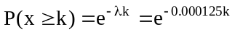 and 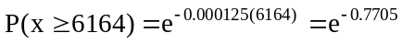 = 0.4628

b. The probability that they will not experience a puncture before getting to Denver (2016 miles):
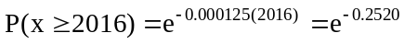 = 0.7772

c. The probability is 0.80 that they will experience a puncture before M miles.
This is most easily done with the computer. We want the inverse of the cumulative probability distribution, and the cumulative probability of interest is 0.80. As shown in the Minitab printout below, there is a 0.80 probability that the next puncture will occur within the next 12,900 miles.

Inverse Cumulative Distribution Function
Exponential with mean = 8000.00
P( X <= x ) x
0.8000 1.29E+04

Accordingly, there is a 0.20 probability that no puncture until at least 12,900 miles from now.
This can also be expressed as: 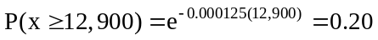

7.86 p/a/m The mean of the exponential distribution is 8.0 minutes. We can use the computer to find the time duration that is exceeded by only 10% of the calls. The cumulative probability of interest is 1 - 0.10, or 0.90. The Minitab printout is shown below.

Inverse Cumulative Distribution Function
Exponential with mean = 8.00000
P( X <= x ) x
0.9000 18.4207

A technical support call must last 18.4207 minutes before it qualifies for redirection to a manager.

7.87 p/a/m For x = minutes between patrol car visits, the mean is 20 minutes and x is exponentially distributed. The probability of the alarm shutting off before the next patrol car arrives is P(x > 15).
Using Minitab to find this probability, the printout and cumulative probabilities are shown below.

Cumulative Distribution Function
Exponential with mean = 20.0000
x P( X <= x )
10.0000 0.3935
15.0000 0.5276
20.0000 0.6321

and P(x > 15) = 1 - P(x ≤ 15) = 1.000 - 0.5276 = 0.4724

INTEGRATED CASES

THORNDIKE SPORTS EQUIPMENT (THORNDIKE VIDEO UNIT THREE)

Let x = weight of the racquet in grams; x is normally distributed with μ = 240 and σ = 10.
For "Graph-Pro Light"
The quantity to be determined is the weight (W) such that only 15% of the racquets are lighter than
W grams, or P(x < W) = 0.15. Referring to the standard normal table, we find that a cumulative area of 0.1500 corresponds most closely to z = -1.04. Now substitute μ = 240, σ = 10, and z = -1.04 into the z-score formula.
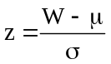 or 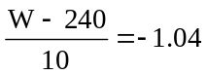 Solving for W: W = 229.6 grams.
Therefore, in order to be classified as a "Graph-Pro Light" racquet, the racquet should weigh less than 229.6 grams.

For "Graph-Pro Stout":
The quantity to be determined is the weight (W) such that only 5% of the racquets are heavier than
W grams, or P(x > W) = 0.05. First, find the value of z corresponding to a cumulative area of
1.0000 - 0.0500 = 0.9500. Referring to the standard normal table, we use interpolation between
z = 1.64 and z = 1.65 and obtain z = 1.645. Now substitute μ = 240, σ = 10, and z = 1.645 into the z-score formula.
or 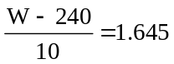 Solving for W: W = 256.45 grams
Therefore, in order to be classified as a "Graph-Pro Stout" racquet, the racquet should weigh more than 256.45 grams.

For "Graph-Pro Regular":
The racquets that weigh between 229.6 and 256.45 grams are classified as "Graph-Pro Regular".

THORNDIKE GOLF PRODUCTS DIVISION

1. We must first determine the probability of "success" (x ≥ 31.00) on any given trial. This is based on the normal distribution with μ = 30.00 and σ = 2.00.
The corresponding z value is (31.00 -30.00)/2.00, or z = 0.50. Referring to the normal table, we find P(z ≥ 0.50) is 1.0000 - 0.6915, or 0.3085. Using Minitab, we obtain the following individual and cumulative binomial probabilities, which have been placed next to each other for purposes of clarity.

BINOMIAL WITH N = 100 P = 0.308500 BINOMIAL WITH N = 100 P = 0.308500
K P( X = K) K P( X LESS OR = K)
13 0.0000 13 0.0000
14 0.0001 14 0.0001
15 0.0001 15 0.0002
16 0.0003 16 0.0005
17 0.0007 17 0.0012
18 0.0014 18 0.0027
19 0.0028 19 0.0054
20 0.0050 20 0.0104
21 0.0085 21 0.0189
22 0.0136 22 0.0324
23 0.0205 23 0.0530
24 0.0294 24 0.0824
25 0.0399 25 0.1222
26 0.0513 26 0.1735
27 0.0627 27 0.2362
28 0.0730 28 0.3092
29 0.0808 29 0.3900
30 0.0853 30 0.4753
31 0.0859 31 0.5613
32 0.0827 32 0.6440
33 0.0760 33 0.7200
34 0.0668 34 0.7868
35 0.0562 35 0.8430
36 0.0453 36 0.8883
37 0.0349 37 0.9232
38 0.0258 38 0.9491
39 0.0183 39 0.9674
40 0.0125 40 0.9799
41 0.0081 41 0.9880
42 0.0051 42 0.9931
43 0.0031 43 0.9962
44 0.0018 44 0.9980
45 0.0010 45 0.9990
46 0.0005 46 0.9995
47 0.0003 47 0.9998
48 0.0001 48 0.9999
49 0.0001 49 1.0000
50 0.0000

2. Using the normal approximation to the binomial distribution, the mean and standard deviation for
x = the number of balls out of 100 that will bounce at least 31.00 inches:

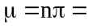100(0.3085) = 30.85 balls

4.6187 balls

Using the normal approximation,
cumulative probabilities for x
when μ = 30.85 and σ = 4.6187:

cumulative
x probability
8.5 0.00000
9.5 0.00000 Repeating the cumulative binomial probabilities:
10.5 0.00001
11.5 0.00001 BINOMIAL WITH N = 100 P = 0.308500
12.5 0.00004 K P( X LESS OR = K)
13.5 0.00009 13 0.0000
14.5 0.00020 14 0.0001
15.5 0.00044 15 0.0002
16.5 0.00095 16 0.0005
17.5 0.00192 17 0.0012
18.5 0.00375 18 0.0027
19.5 0.00700 19 0.0054
20.5 0.01252 20 0.0104
21.5 0.02147 21 0.0189
22.5 0.03531 22 0.0324
23.5 0.05576 23 0.0530
24.5 0.08459 24 0.0824
25.5 0.12336 25 0.1222
26.5 0.17314 26 0.1735
27.5 0.23413 27 0.2362
28.5 0.30545 28 0.3092
29.5 0.38503 29 0.3900
30.5 0.46980 30 0.4753
31.5 0.55596 31 0.5613
32.5 0.63955 32 0.6440
33.5 0.71693 33 0.7200
34.5 0.78531 34 0.7868
35.5 0.84298 35 0.8430
36.5 0.88939 36 0.8883
37.5 0.92504 37 0.9232
38.5 0.95117 38 0.9491
39.5 0.96945 39 0.9674
40.5 0.98166 40 0.9799
41.5 0.98944 41 0.9880
42.5 0.99417 42 0.9931
43.5 0.99692 43 0.9962
44.5 0.99844 44 0.9980
45.5 0.99924 45 0.9990
46.5 0.99965 46 0.9995
47.5 0.99984 47 0.9998
48.5 0.99993 48 0.9999
49.5 0.99997 49 1.0000
50.5 0.99999
51.5 1.00000

Yes, the probabilities are quite similar. In the normal approximation, the probability associated
with x = 40 successes corresponds to the area between x = 39.5 and x = 40.5, and so on.

3. Based on the assumed underlying distribution (normal, with μ = 30.00 and σ = 2.00 inches), the x value that will be exceeded only 5% of the time can be computed as μ + 1.645σ,
or 30.00 + 1.645(2.00) = 33.29 inches. Likewise, we can find the x value that will be exceeded 95% of the time as μ - 1.645σ, or 30.00 - 1.645(2.00) = 26.71 inches.We can also use the computer to obtain these values to more decimal places, as shown in the Minitab printout below.

Inverse Cumulative Distribution Function
Normal with mean = 30.0000 and standard deviation = 2.00000
P( X <= x ) x
0.0500 26.7103
0.9500 33.2897

4. The probability that any given ball will score below 26.7103 inches is 0.05, as shown in the response to question 3, above. For 3 consecutive balls, the probability that all 3 will score below 26.7103 inches is 0.05(0.05)(0.05), or 0.000125.

5. and 6. Plot of bounce test results for balls 1 to 240:
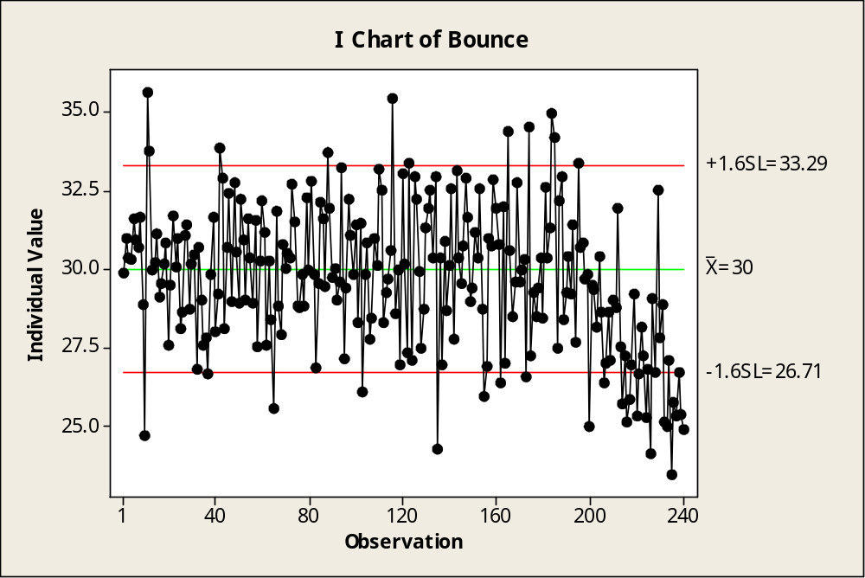

7. and 8. It would appear that about 90% of the balls are within the expected upper and lower boundaries (shown in the graph as 33.29 and 26.71, respectively), at least for the first 200 produced. However, in the 200 to 240 range of production, there seem to be an inordinate number that fall below the lower boundary. The "liveliness" of the balls has decreased from those produced earlier, and the machine may require an adjustment that results in the balls having higher scores on the bounce test.

